1. View of all API

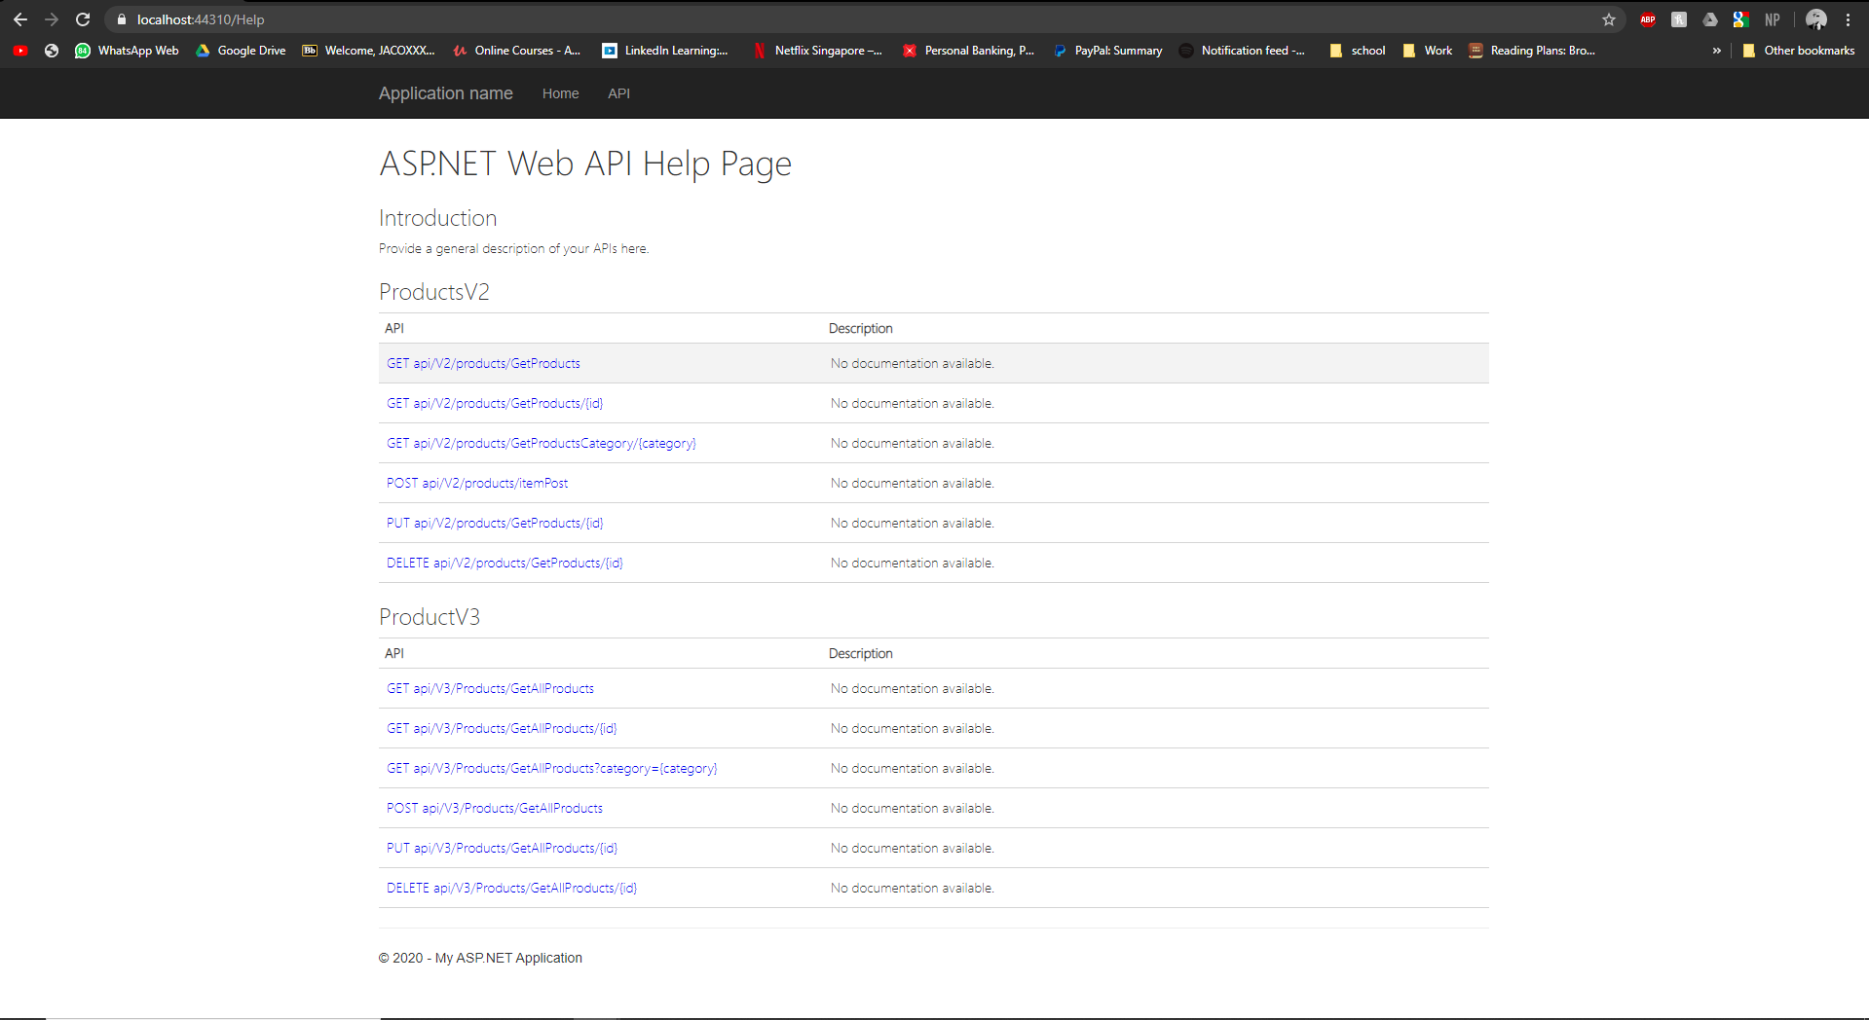

1. Demo CRUD operations

Get product by id, id=3

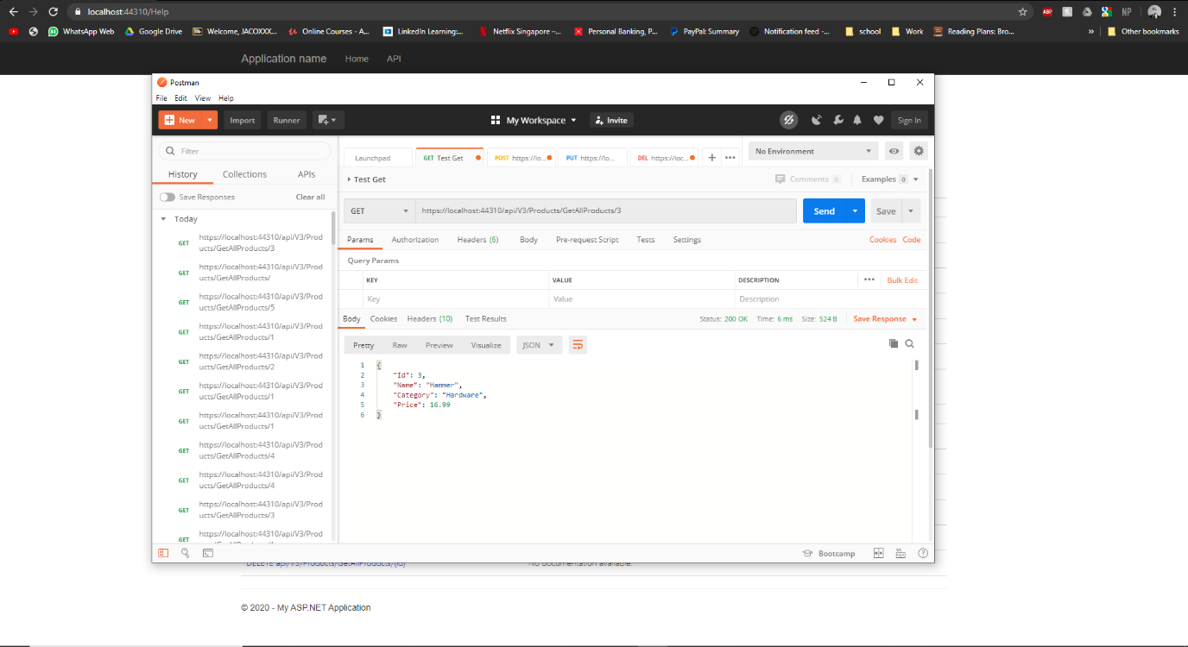

Get all products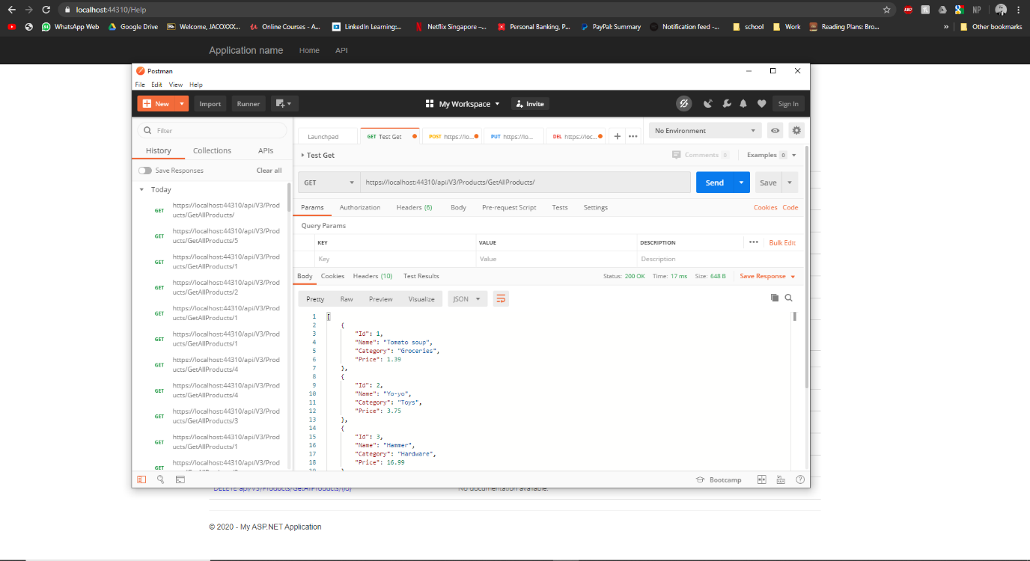

Post New product ”Miso”, “Japanese”, “5.0”. Id= 4

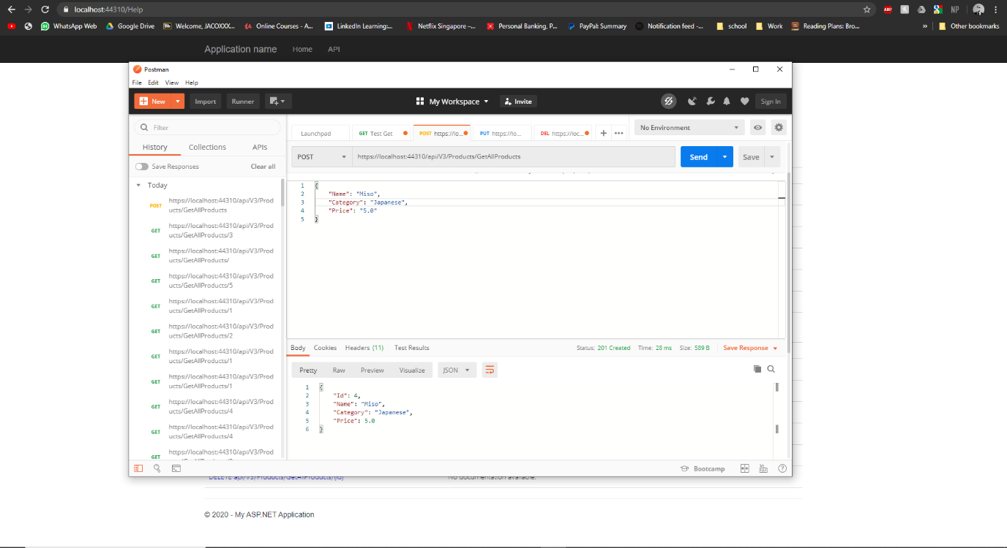

Get product by category, category = japanese

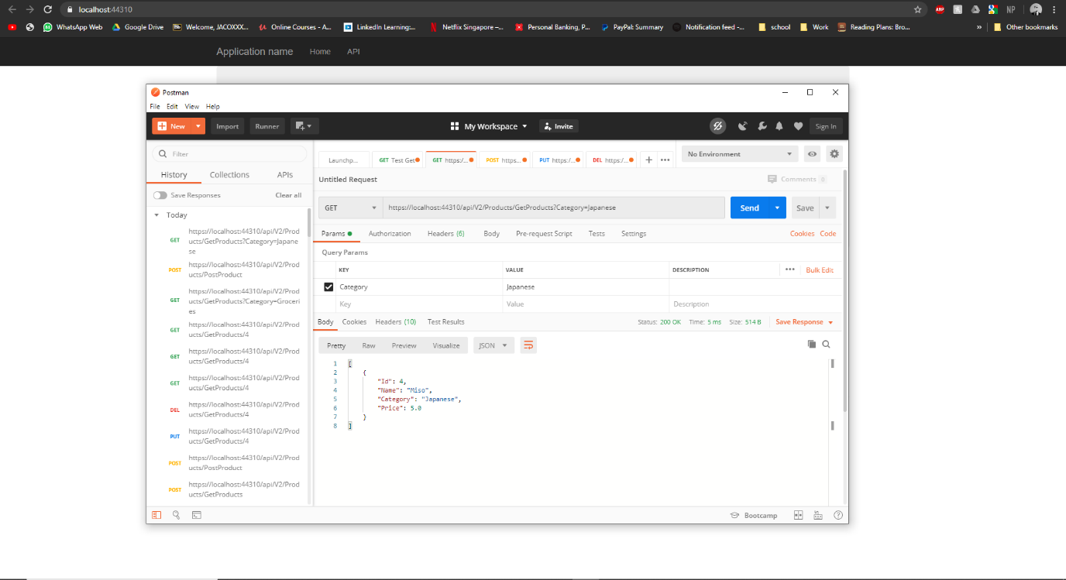

Update Product id= 4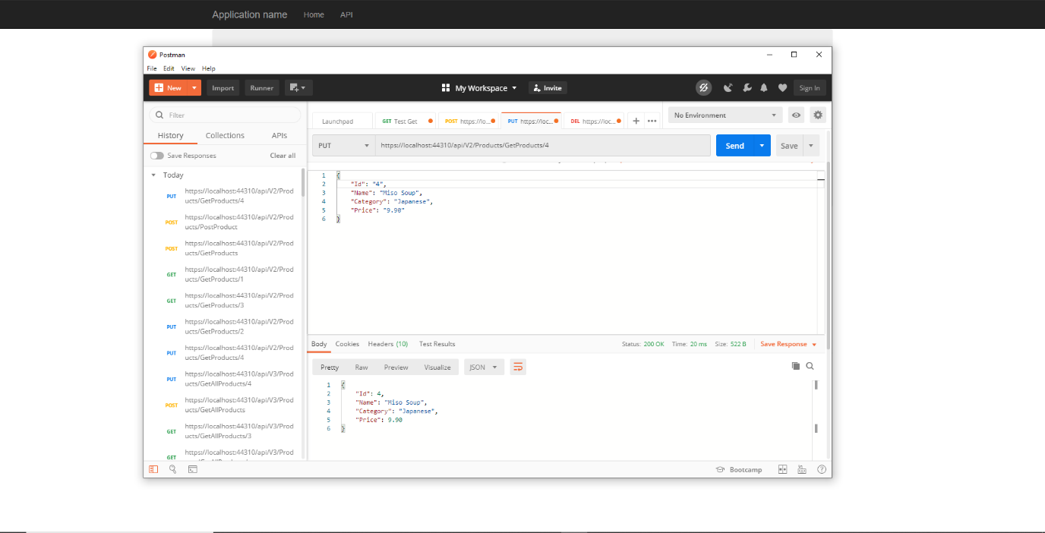

1. Demo overposting & underposting handled and correct outcomes - POSTMAN

Overposting

In new ASP.net version, overposting error handled internally.

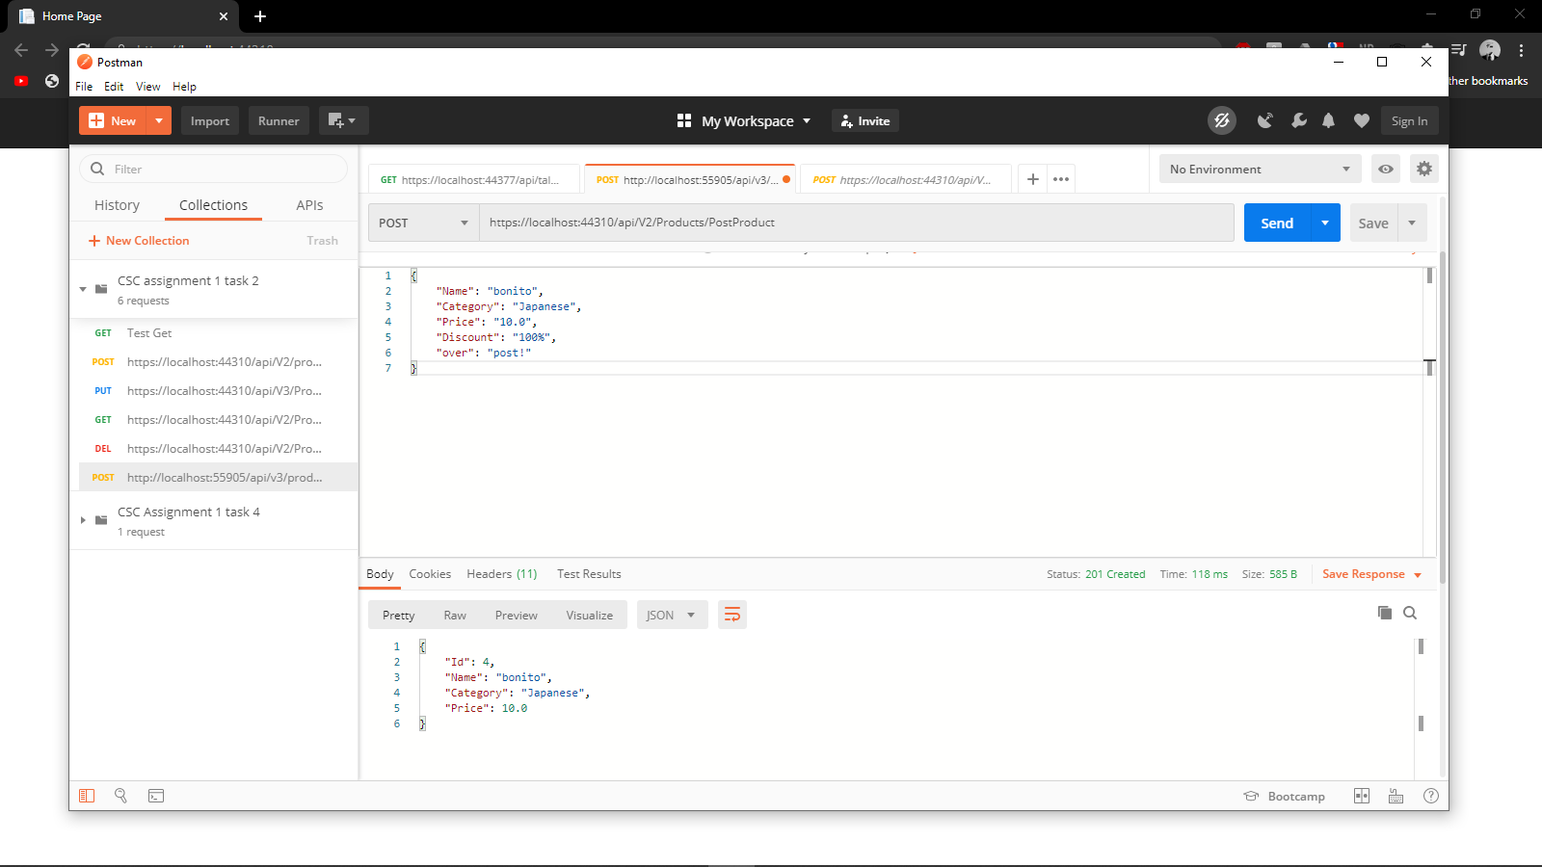

Underposting